SIMULATION EXERCISE
MASTER SCENARIO
- Pakistan contributes to less than 1% of worldwide greenhouse gas emissions, yet it is listed among the ten countries most susceptible to the impacts of climate change. In recent decades, the country has faced an increasing frequency of climate-related incidents, such as unexpected flooding, intense and out-of-season snowfall, an early start to summer, more frequent heatwaves, wildfires, cyclones, rapid glacier melting, and smog.
- According to Meteorological projections for six months (July-Dec) of 2025 ENSO is projected to remain in a neutral phase during July–October 2025, with a gradual shift toward La Niña conditions by November–December which may influence wind patterns and cyclone activity in the Arabian Sea. The Indian Ocean Dipole (IOD) is expected to stay in a negative phase during the early part of the period (July–September), affecting moisture transport and atmospheric circulation over the Arabian Sea. during mid-year, influencing wind patterns over the Arabian Sea.
- According to the seasonal outlook based on the emerging patterns and multi-model ensemble projections, Pakistan is expected to experience above-normal temperatures overall, gradually cooling toward year-end, with generally low to moderate rainfall (October to December) mainly from sporadic western disturbances.
- Sea Surface Temperatures (SSTs) in the Arabian Sea are expected to remain 2–3 °C above average through much of the season, providing favorable thermal conditions for tropical cyclone formation. The cyclogenesis window in the Arabian Sea is likely to remain active during May-June, with a secondary peak of cyclone probability during September–October, coinciding with the post-monsoon cyclone season.
- Elevated SSTs, neutral ENSO, and conducive atmospheric conditions collectively point toward an above-average likelihood of cyclonic activity to develop in the Arabian Sea, some of which could pose a threat to Pakistan’s coastal areas in the late-year period.
SCENARIO - Cyclone
- The Tech team anticipates several conditions will become favorable for cyclone development in the Arabian Sea (Sept-Oct) higher Sea Surface Temperature (SST) anomalies in the months of September–October (sometimes extending into early November), in the Arabian sea particularly north eastern region; thus, indicating higher probabilities of cyclonic conditions in the year 2025. The evolving La Niña conditions are driving warmer-than-average SSTs, with anomalies ranging between 2–4°C. This substantial warming, low vertical wind shear and ` provides a conducive environment for cyclonic activity. The elevated SSTs not only energize potential cyclonic systems but also prolong their lifespan, allowing them to gain strength as they traverse the Arabian Sea. Historical patterns suggest that evolving La Niña conditions correlate with an increased frequency and intensity of tropical cyclones in the region. This anomaly is expected to amplify the probability of Severe Cyclonic Storms (Category 3 or higher) forming and intensifying near Pakistan's coastline.
DEW Issue Date | Validity | Indicator Monitored | Remarks
10th June | August to Sept | Higher Sea Surface Temperature (SST) in the North Eastern Arabian Sea is expected | Increased probability of cyclogenesis in the North Arabian Sea.
10th August | Sept to Oct | Significant increase in SST, higher upper-level divergence, and low vertical wind shear | Cyclonic circulation likely to form in Sept-Oct.
22th September | 1–15 Oct | SST above 27°C, positive IOD, converging winds, low vertical wind shear, and strong Indian Subtropical Ridge | Severe cyclonic storms (Category 3 or higher) expected to track towards the Sindh coast.

Disaster Early Warning Notification
Issued Date: August 10
Validity Period: Sept-Oct
Indicators & Monitoring
Sea Surface Temperature (SST): Significant increase observed.
Upper-Level Divergence: Higher than normal.
Vertical Wind Shear: Low, favorable for cyclone formation.
Forecast & Possible Impact
A cyclonic circulation is likely to form in Oct. The cyclone may follow two possible trajectories, details to be refined with further monitoring.
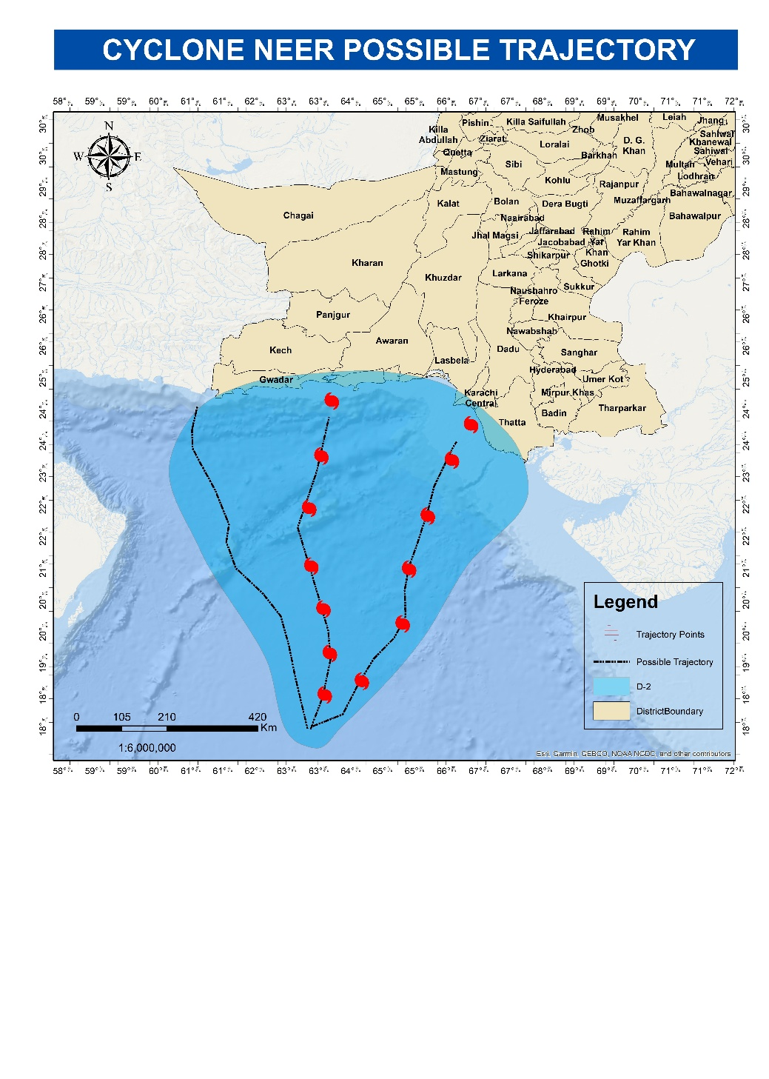

Cyclone Neer

Alert | Date | System Status | Location | Wind Gusts | Key Details
A | 27 September | Low-Pressure System (LPS) | 691 km SW of Karachi | 30 km/h | Expected to strengthen into a Tropical Depression by 28 September.
B | 28 September | Tropical Depression (TD) | 578 km SW of Karachi | 60 km/h | Trajectory towards Sindh coast; likely to become a storm system.
C | 29  September | Tropical Storm System (TSS) | 473 km SW of Karachi | 90 km/h | Likely to intensify into a Category 1 cyclone; named "Neer"
D | 30 September | Category 1 Cyclone (Neer) | 345 km southwest of Thatta | 125 km/h | Expected to strengthen into a Category 2 cyclone.
E | 1 October | Category 2 Severe Cyclone (Neer) | 239 km southwest of Thatta | 160 km/h | Likely to intensify into a Category 3 cyclone.
F | 2 October | Category 3 Extremely Severe Cyclone (Neer) | 115 km West of Thatta | 190 km/h | Reached peak intensity; expected to weaken to Category 2 at landfall on 3 October near Thatta
G | 3 October | Category 2 Cyclone (Neer) | Near Karachi and Thatta (landfall expected) | 165 km/h | Landfall expected;6.1million exposed in immediate zone;

Alert A
(Issue Date: 27 September)
A Low-Pressure System (LPS) developed in the western Arabian Sea on 27 September 2025. Currently, the system is located approximately 691 km SW of Karachi. Due to conducive environmental conditions, including higher sea surface temperatures (28°C), low vertical wind shear, increased upper-level divergence, a dominant Indian subtropical ridge, and strong convective currents, the system is expected to intensify into a Tropical Depression by 28 September. It is anticipated to move towards the Sindh coast.
Alert B
(Issue Date: 28 September)
A Tropical Depression (TD) has developed over the eastern Arabian Sea, with maximum sustained wind gusts of 60 km/h. The system is expected to intensify further due to favorable environmental conditions. It is currently located approximately 578 km SW of Karachi. Most models and bathymetric analyses indicate that the system will maintain its trajectory towards the Sindh coast and strengthen into a storm system.
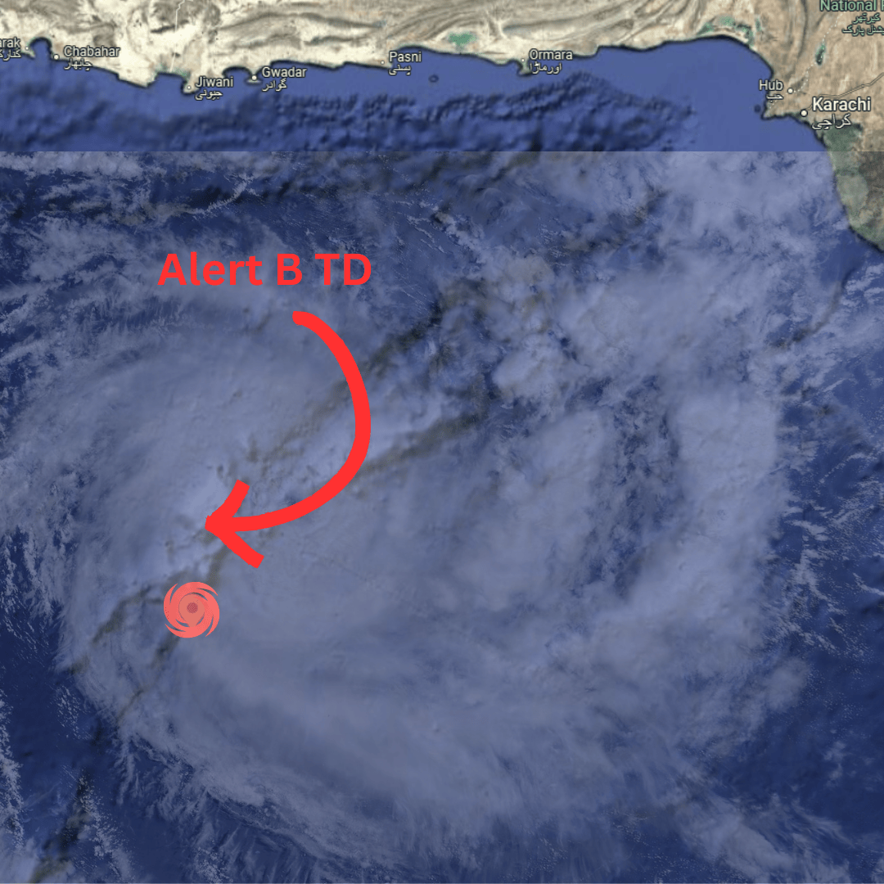

Alert C
(Issue Date: 29 September)
The Tropical Storm System (TSS) over the eastern Arabian Sea is intensifying, with maximum sustained wind gusts of 90 km/h. The storm's eye is currently located 473 km southwest of Karachi. According to most models, meteorological and bathymetric analyses, the system will continue moving towards the Sindh coast and is likely to develop into a Tropical Cyclonic Storm System (Category 1 cyclone). As per the WMO’s international taxonomy for cyclogenesis, the cyclone will be named “Neer.”
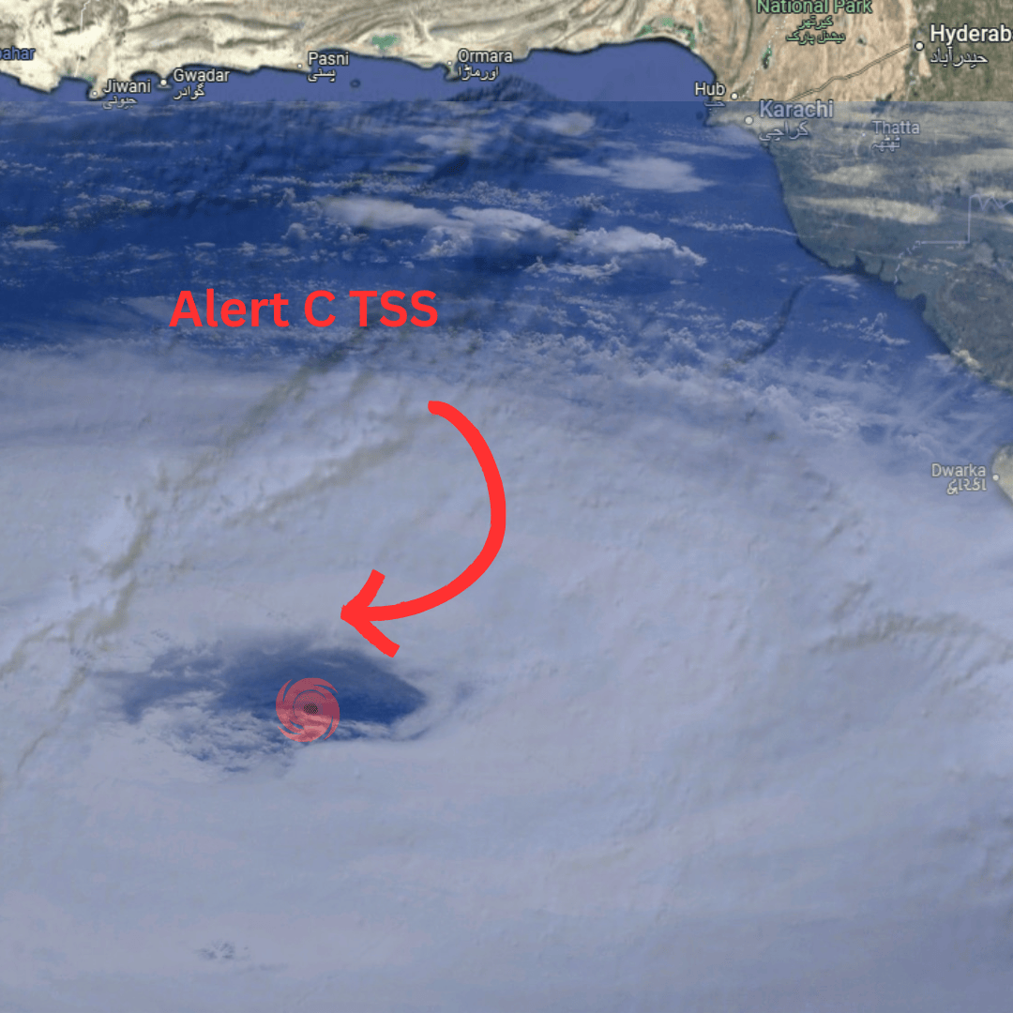

Alert D
(Issue Date: 30 September)
Category 1 Cyclonic Storm Neer over the eastern Arabian Sea is further intensifying, with maximum sustained wind gusts of 125 km/h. The eye is currently located 345 km southwest of Thatta. Most models and analyses indicate that the system will maintain its trajectory towards the Sindh coast and strengthen into a Severe Tropical Cyclonic Storm System (Category 2 cyclone).
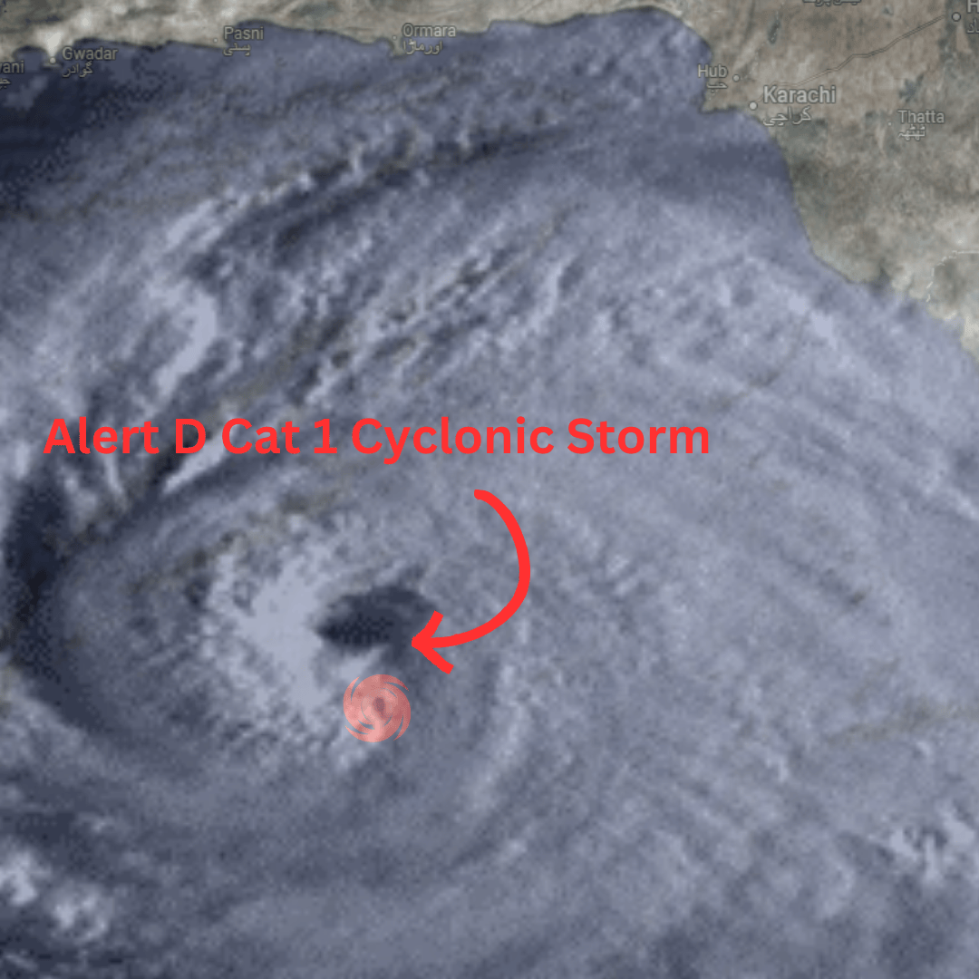

Alert E
(Issue Date: 1 October)
Category 2 Severe Cyclonic Storm Neer over the eastern Arabian Sea is intensifying further, with maximum sustained wind gusts of 160 km/h. The storm's eye is currently located 239 km southwest of Thatta. Models and analyses suggest that the system will continue towards the Sindh coast and develop into a Category 3 Severe Tropical Cyclonic Storm.
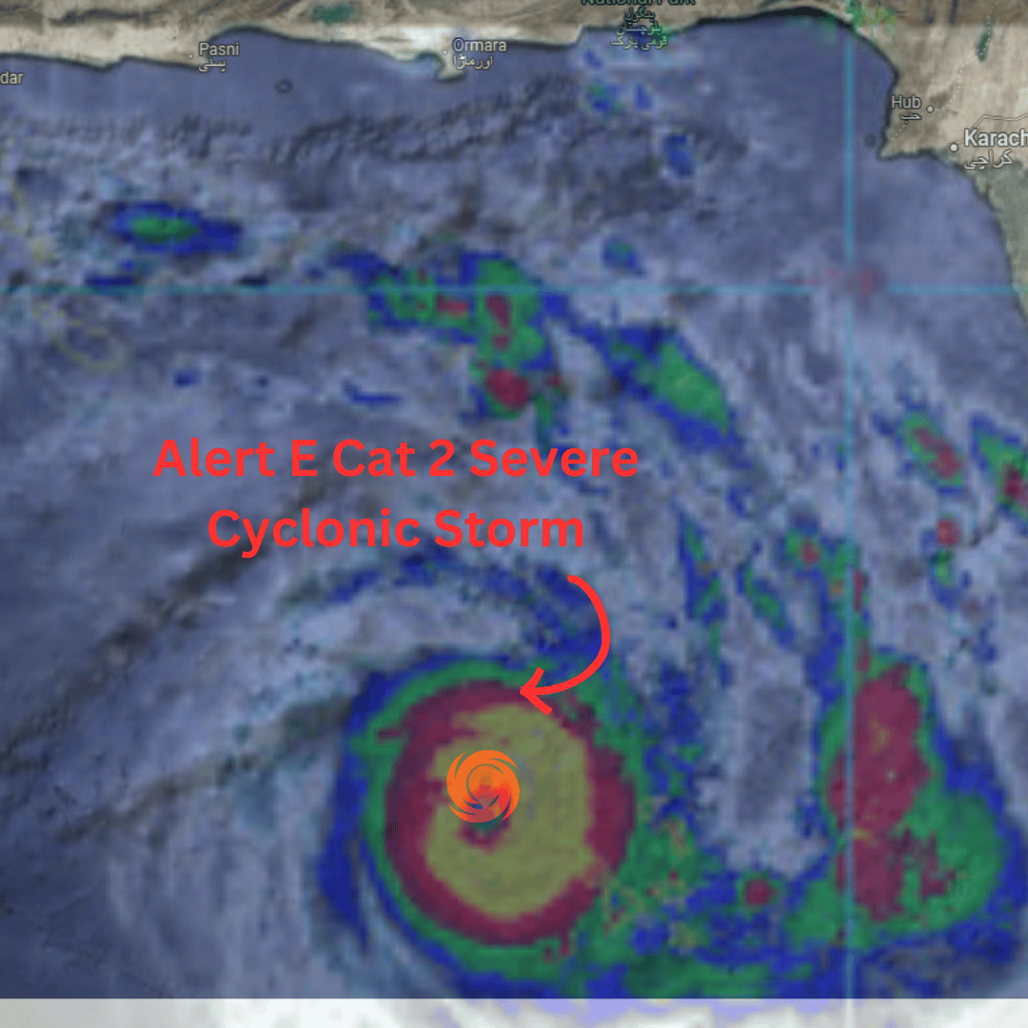

Alert F
(Issue Date: 2 October)
Category 3 Extremely Severe Cyclonic Storm Neer over the north-eastern Arabian Sea is currently located 115 km West of Thatta. The cyclone has reached its peak intensity, with maximum wind gusts of 190 km/h. As the cyclone approaches land, it is expected to weaken and make landfall near Karachi and Thatta on 3 October as a Category 2 Cyclonic Storm.

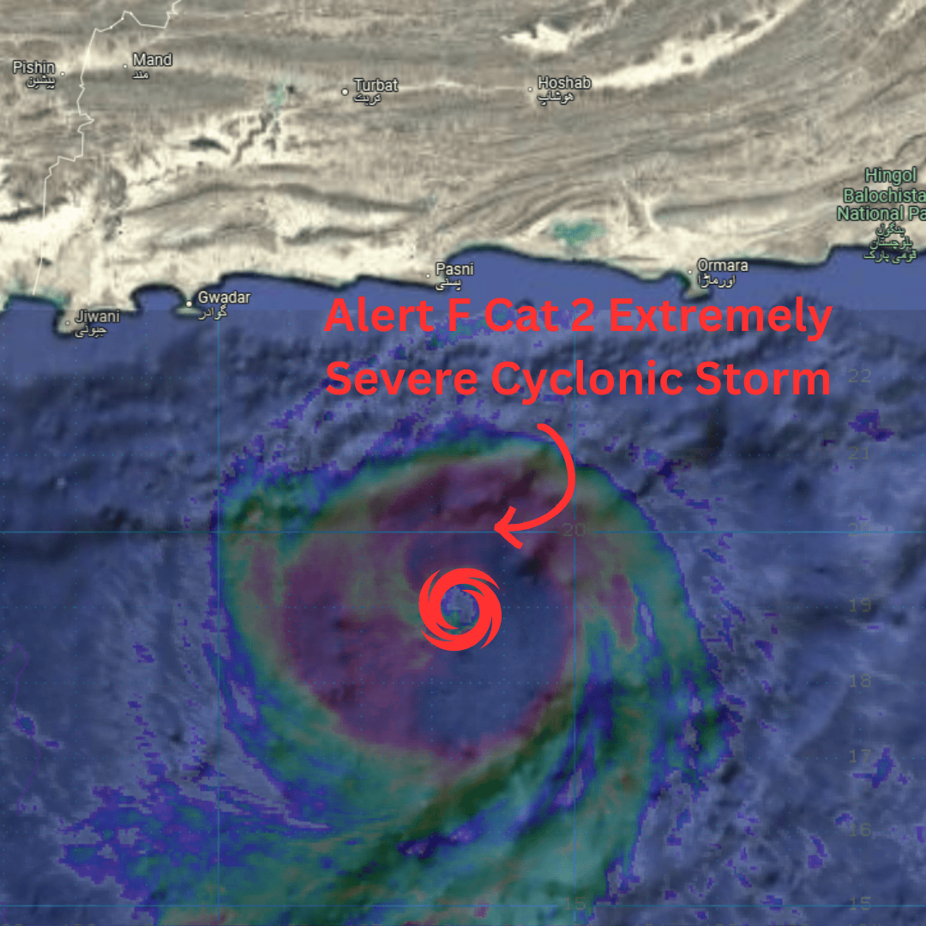

Alert G
(Issue Date: 28th May)
Category 2 Severe Tropical Cyclone Neer is over the Arabian Sea and is expected to make landfall between Karachi and Thatta in the evening of 3 October, with maximum wind gusts of 165 km/h. The estimated population in the immediate landfall zone is approximately 6.1 million.
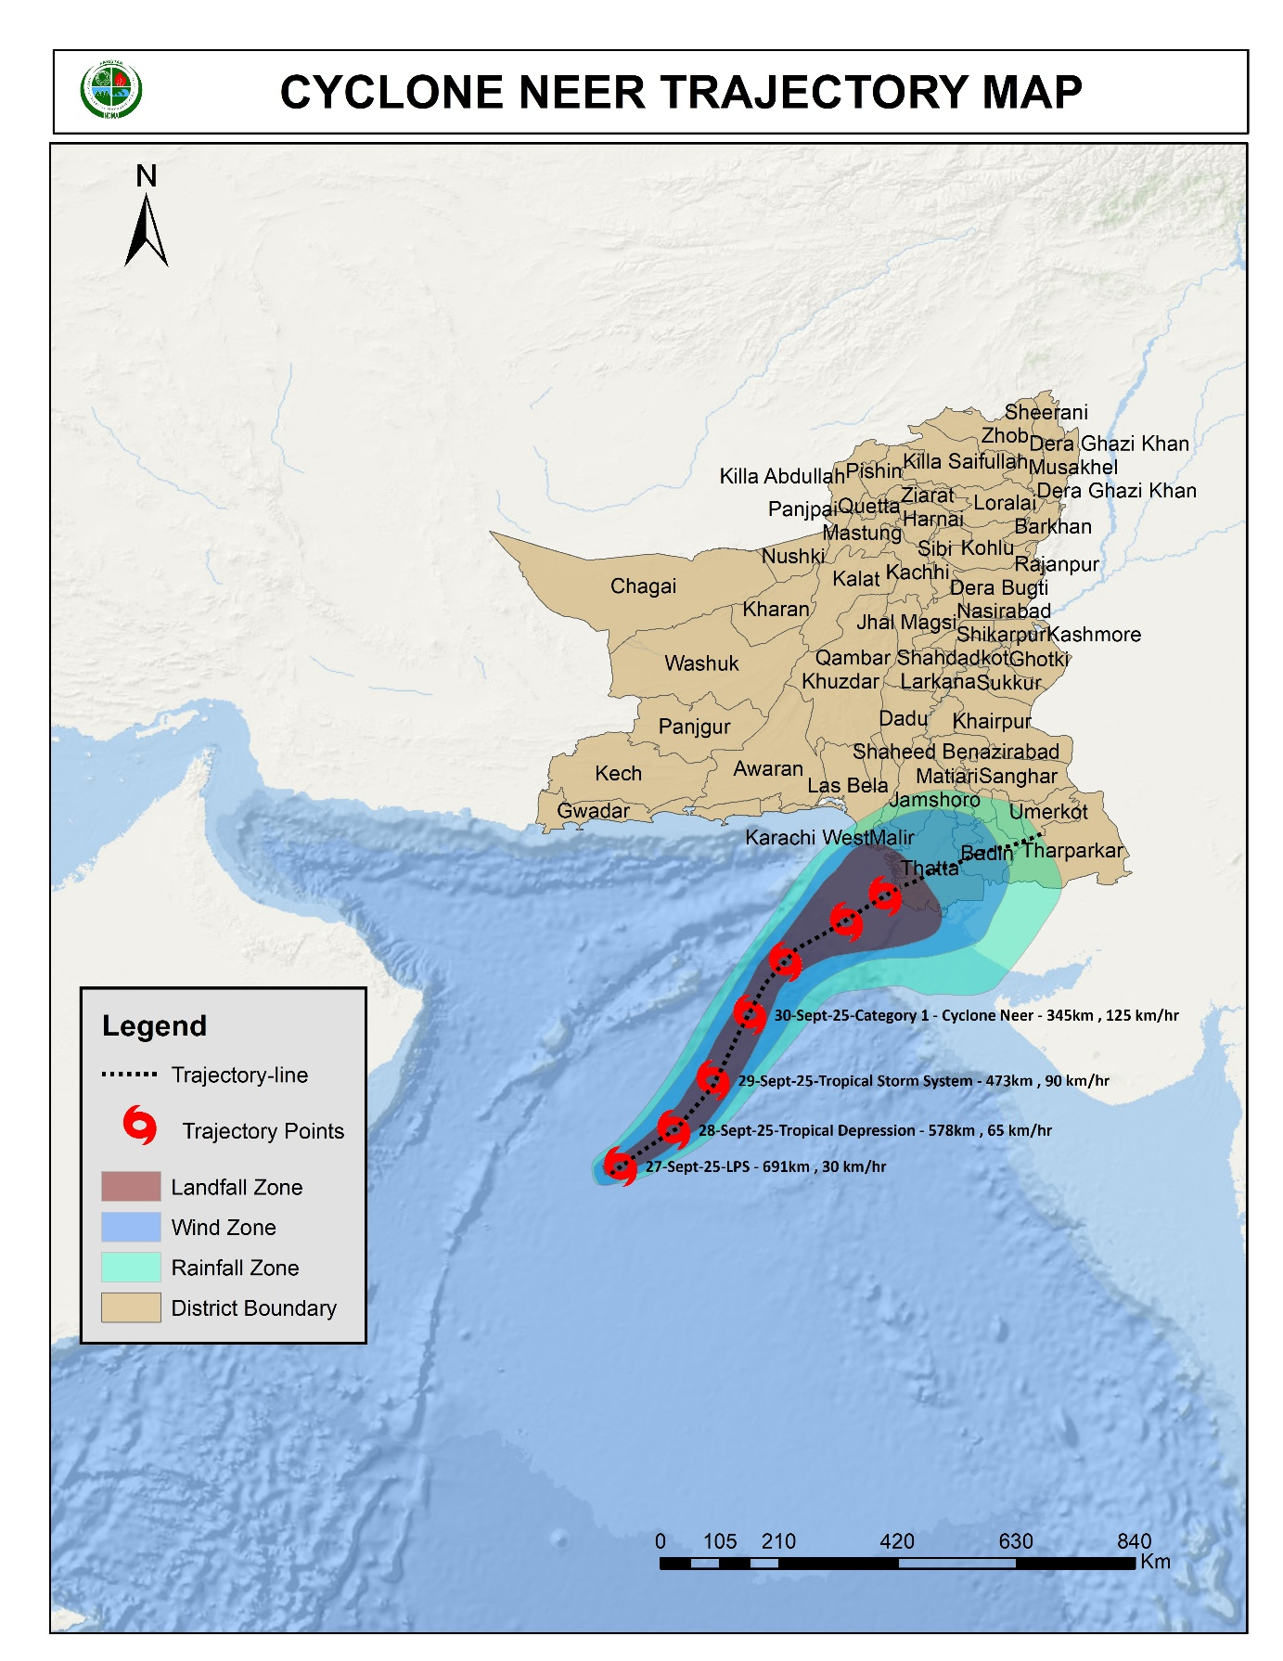

Exposure Category | Exposure to the Immediate landfall | Total exposure to the immediate landfall, wind and rain effect
Population | 6.1 Mil | 21.4 million
Health Facilities | 38 | 99
Educational Facilities | 518 | 2473
Airport | 0 | 3
Road Network in km | 2494 km | 7748 km
Communication Towers | 1985 | 5649
Bridges | 0 | 0
Fisheries | 500 small boats, 20 trawlers
Marine Vessels & Cargo | high impact on 10 vessels and moderate impact on 5
Loose Structures | High damage to hoardings and sign boards
Power Outages | 65% areas likely affected

